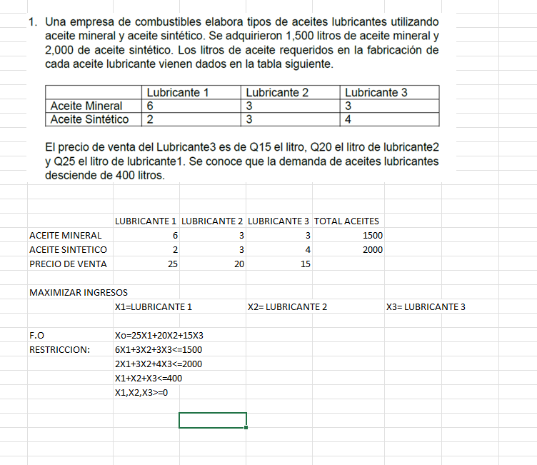

**Restricción 1:** Tiene signo "≤" (menor igual) por lo que se agregará la variable de holgura S1.

**Restricción 2:** Tiene signo "≤" (menor igual) por lo que se agregará la variable de holgura S2.

**Restricción 3:** Tiene signo "≤" (menor igual) por lo que se agregará la variable de holgura S3.

* A continuación, se muestra el problema en la forma estándar. Se colocará el coeficiente 0 (cero) donde corresponda para crear nuestra matriz:
* **Función Objetivo**
* Maximizar: Z = 25X1 + 20X2 + 15X3 + 0S1 + 0S2 + 0S3
* **Sujeto a:**
* 6X1 + 3X2 + 3X3 + 1S1 + 0S2 + 0S3 = 1500
* 2X1 + 3X2 + 4X3 + 0S1 + 1S2 + 0S3 = 2000
* 1X1 + 1X2 + 1X3 + 0S1 + 0S2 + 1S3 = 400
* X1, X2, X3, S1, S2, S3 ≥ 0

### Matriz Inicial

|  |  |  |  |  |  |  |  |  |
| --- | --- | --- | --- | --- | --- | --- | --- | --- |
| **Tabla 1** | **Cj** | 25 | 20 | 15 | 0 | 0 | 0 |  |
| **Cb** | **Base** | **X1** | **X2** | **X3** | **S1** | **S2** | **S3** | **R** |
| 0 | **S1** | **6** | 3 | 3 | 1 | 0 | 0 | 1500 |
| 0 | **S2** | 2 | 3 | 4 | 0 | 1 | 0 | 2000 |
| 0 | **S3** | 1 | 1 | 1 | 0 | 0 | 1 | 400 |
|  | **Z** | -25 | -20 | -15 | 0 | 0 | 0 | 0 |

Ingresa la variable **X1** y sale de la base la variable **S1**. El elemento pivote es **6**

### Iteración 1

|  |  |  |  |  |  |  |  |  |
| --- | --- | --- | --- | --- | --- | --- | --- | --- |
| **Tabla 2** | **Cj** | 25 | 20 | 15 | 0 | 0 | 0 |  |
| **Cb** | **Base** | **X1** | **X2** | **X3** | **S1** | **S2** | **S3** | **R** |
| 25 | **X1** | 1 | 1/2 | 1/2 | 1/6 | 0 | 0 | 250 |
| 0 | **S2** | 0 | 2 | 3 | -1/3 | 1 | 0 | 1500 |
| 0 | **S3** | 0 | **1/2** | 1/2 | -1/6 | 0 | 1 | 150 |
|  | **Z** | 0 | -15/2 | -5/2 | 25/6 | 0 | 0 | 6250 |

Ingresa la variable **X2** y sale de la base la variable **S3**. El elemento pivote es **1/2**

### Iteración 2

|  |  |  |  |  |  |  |  |  |
| --- | --- | --- | --- | --- | --- | --- | --- | --- |
| **Tabla 3** | **Cj** | 25 | 20 | 15 | 0 | 0 | 0 |  |
| **Cb** | **Base** | **X1** | **X2** | **X3** | **S1** | **S2** | **S3** | **R** |
| 25 | **X1** | 1 | 0 | 0 | 1/3 | 0 | -1 | 100 |
| 0 | **S2** | 0 | 0 | 1 | 1/3 | 1 | -4 | 900 |
| 20 | **X2** | 0 | 1 | 1 | -1/3 | 0 | 2 | 300 |
|  | **Z** | 0 | 0 | 5 | 5/3 | 0 | 15 | **8500** |

La solución óptima es Z = 8500

X1= 100, X2= 300, X3= 0, S1= 0, S2= 900, S3= 0